**Insight 1 :** Cancellation By states

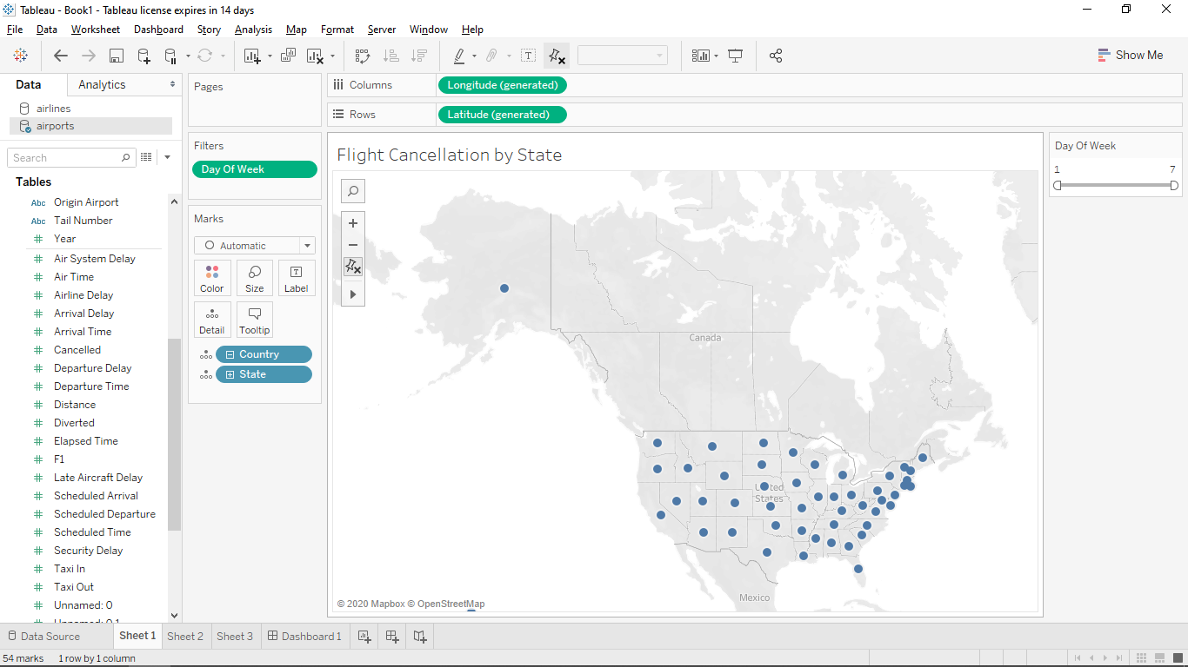

**Screenshot 1 : [Before Filter]**

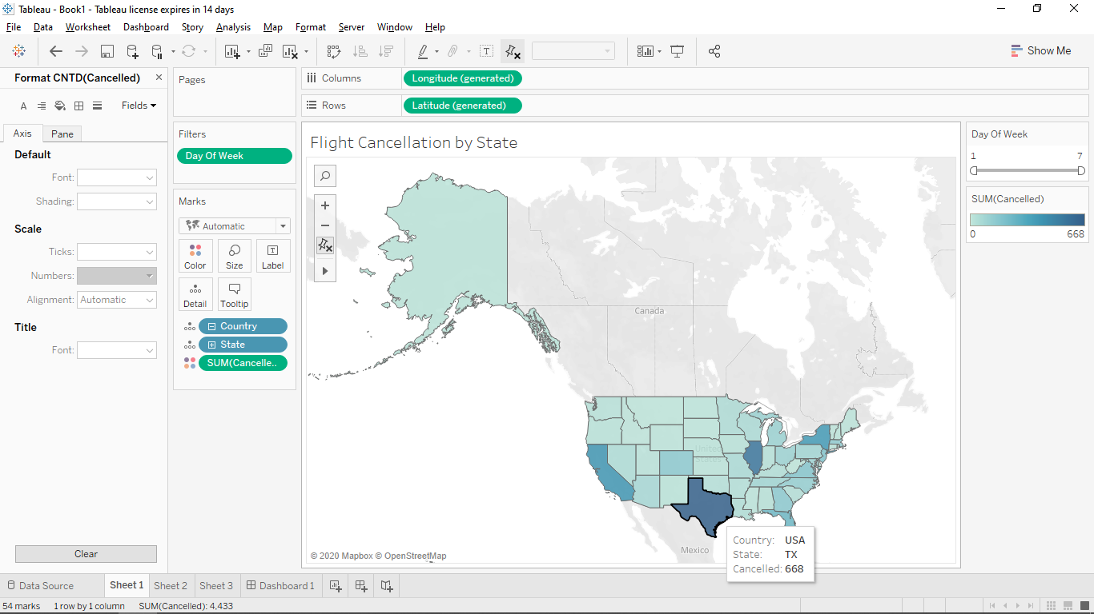

**Screenshot 2 : After applying SUM(Cancelled)**

**Summary:** From this Insight we can see that most of the cancellation happen in California (33331) and Texas (32612). And West Virginia had the fewest number of cancellations with only 103.

**Design:** I have chosen Map to visualize this Insight III, because the geographical data like Country, State, City can be visualized effectively than other graphs. The Map in Blue shades highlights with darker the number of flight cancellation number increases; the blue color is the wat make sure color palettes should work for color blindness.

**Insight 2 :** Line Graph for showing the cancellation trend in the year 2015.

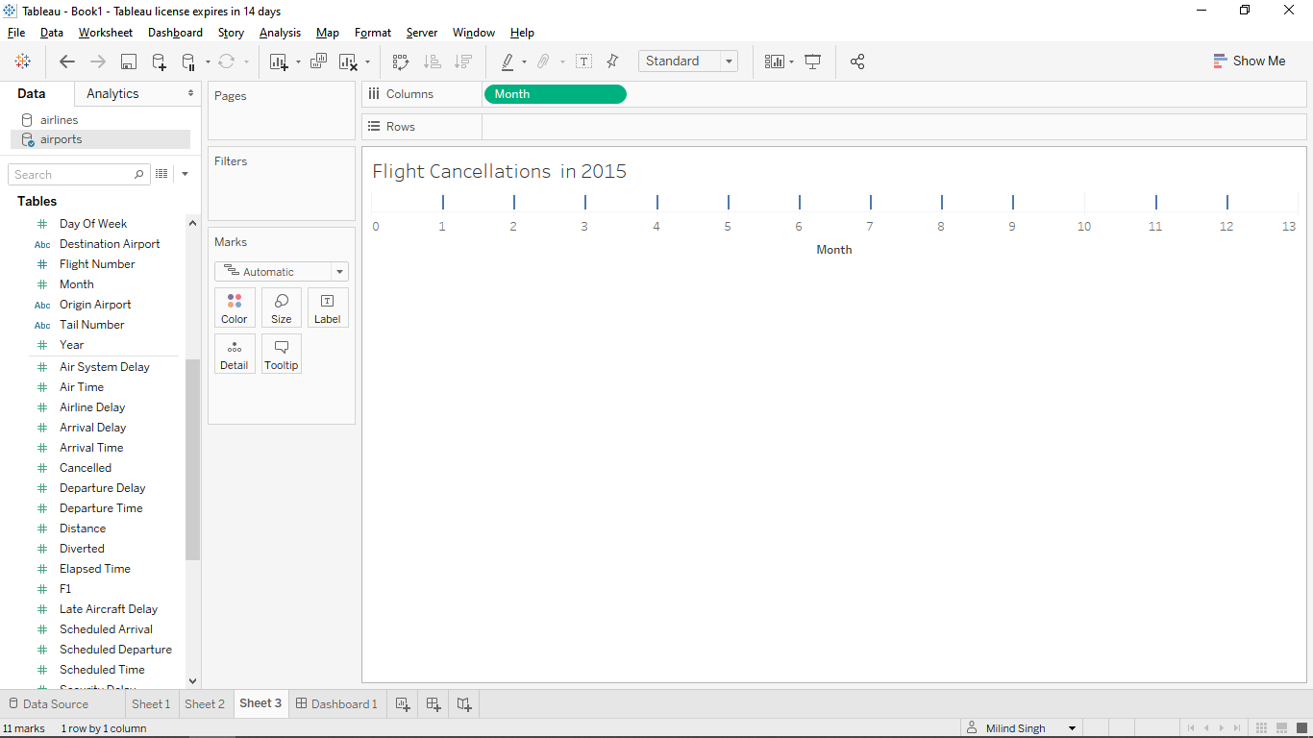

**Screenshot 1 : Before adding Rows**

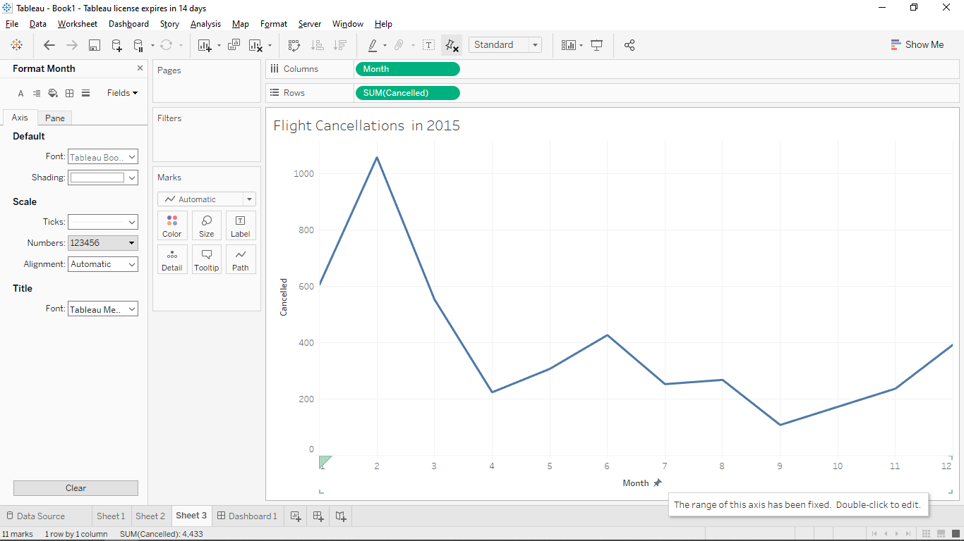

**Screenshot 2 : After adding rows**

**Observation:** From this graph, we can see that in 2015, February is the month with the

most cancellations (1,058) followed by January(605). And September recorded the lowest flight cancellation.

**Design:** I have chosen line graph to visualize this Insight IV, because this works best to view trend of data over the time(Continuous data). The graph in Blue to make sure color palettes should work for colorblindness also added one tooltip that is sum of diverted Airlines.

**Insight 3:** Cancellation by states having bar graph to show counting.

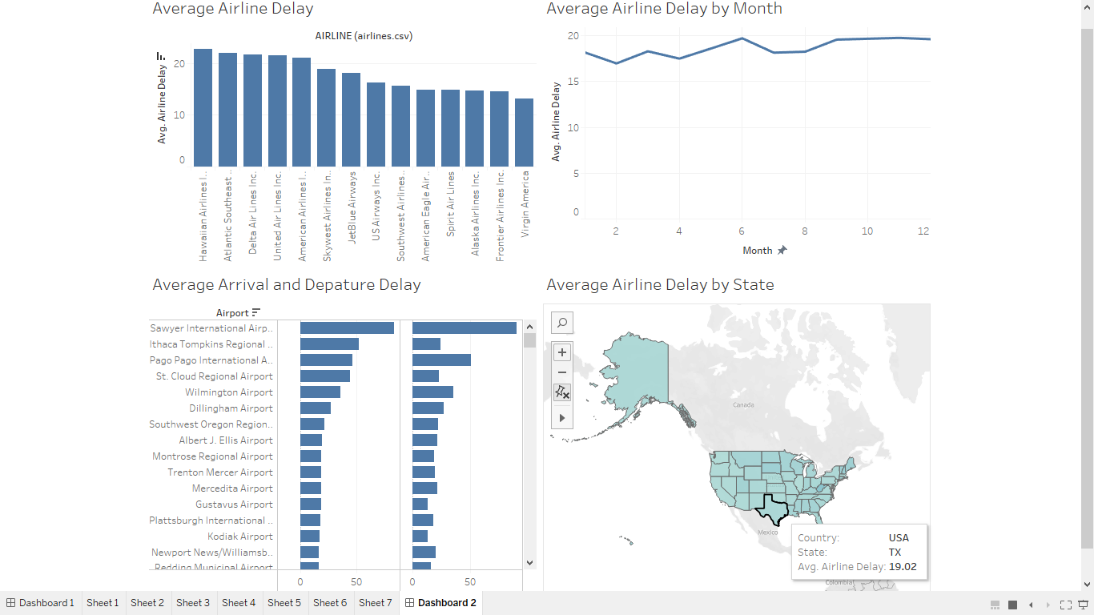

**Screenshot 1: After arranging charts on a single dashboard.**

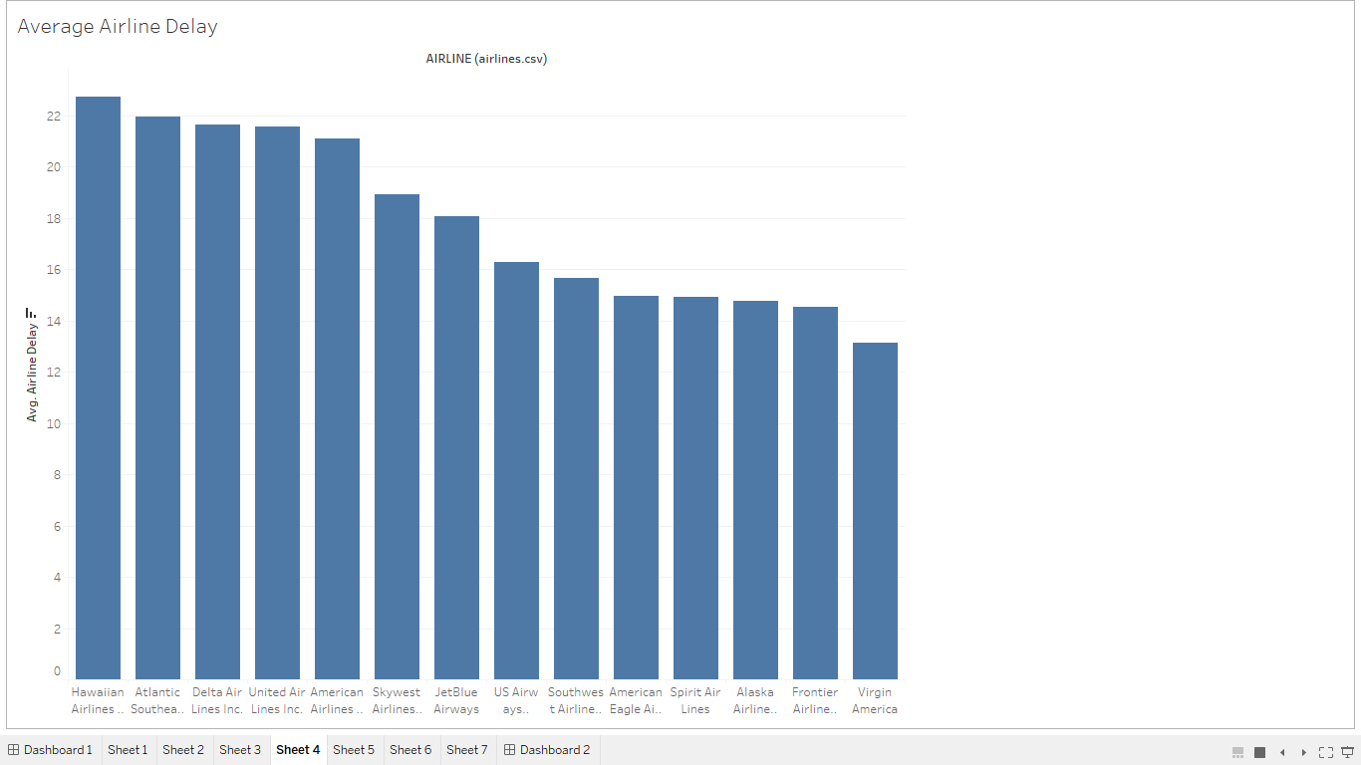 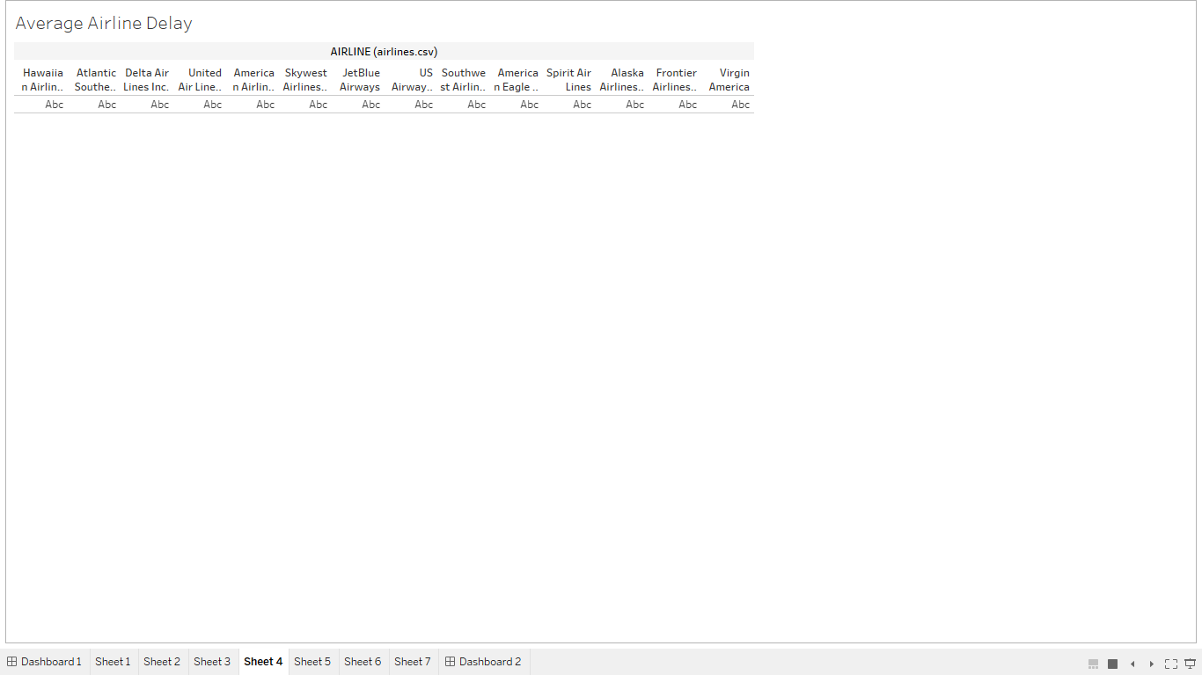

>> Average Airline Delay with filter >>and without filter

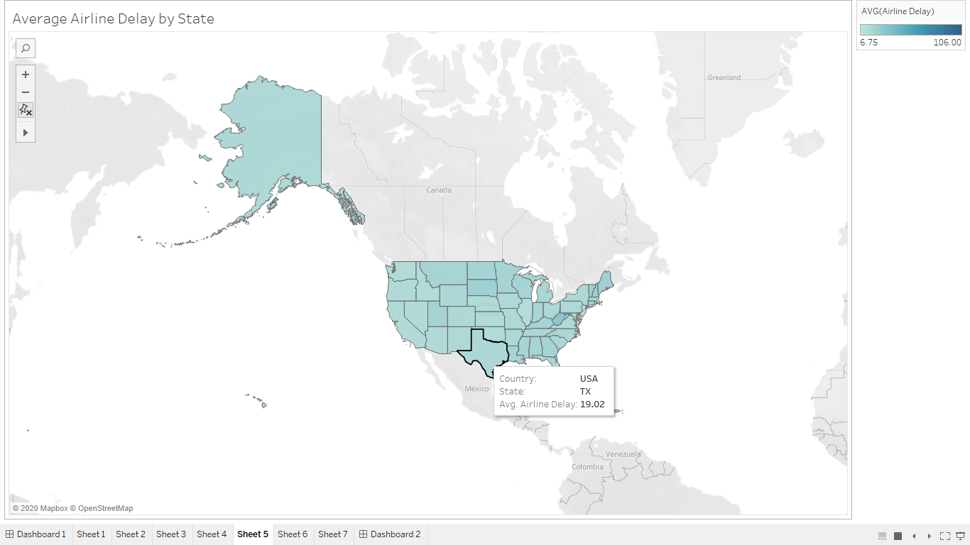 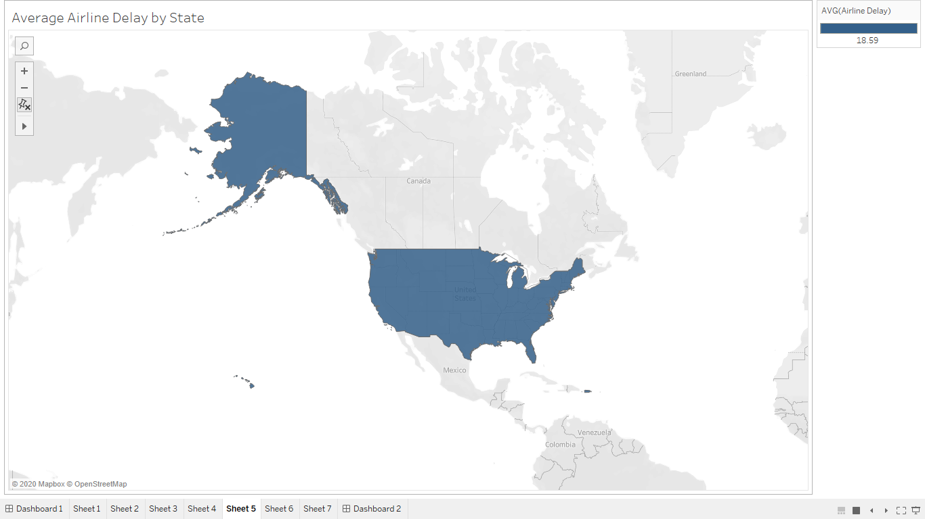

>> Average airline delay by state with filter >>and without adding state Column.

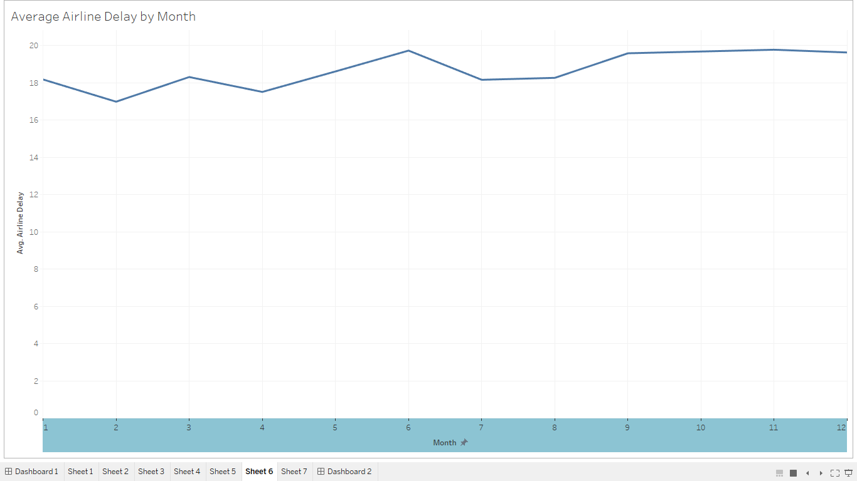 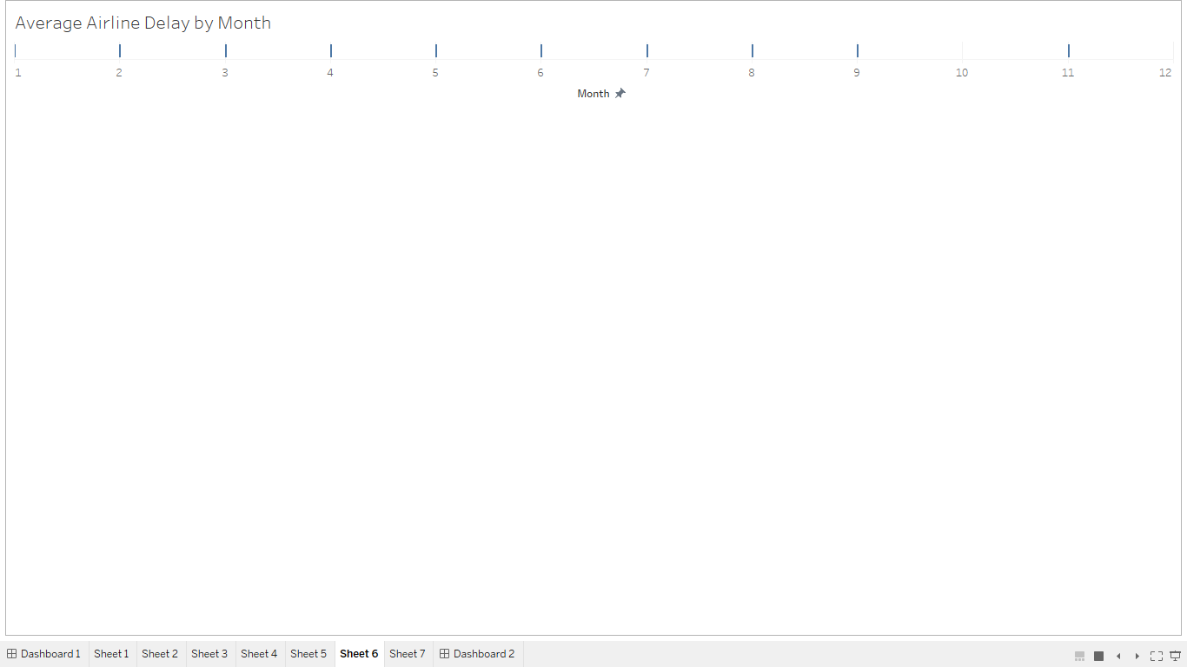

>> Average airline delay by month with filter >>and without adding avg airline delay filter.

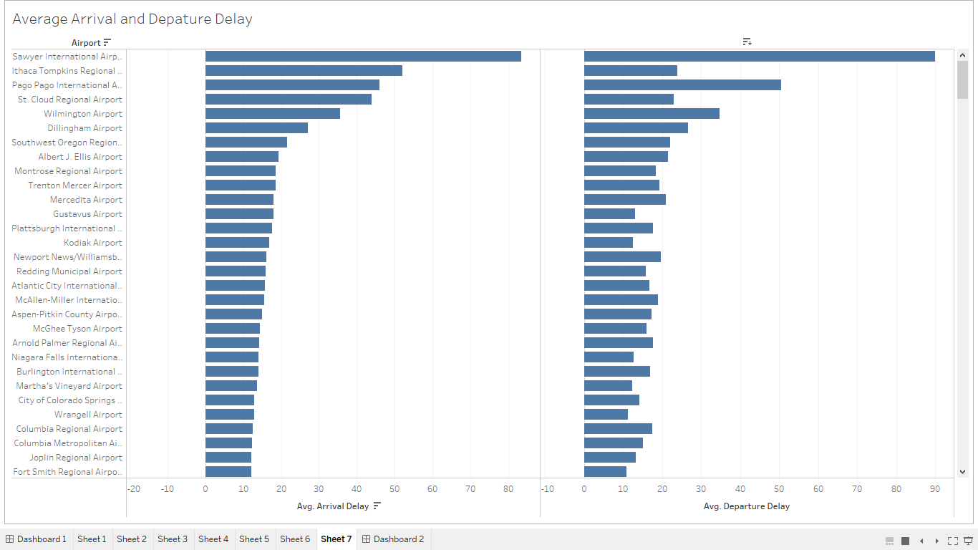 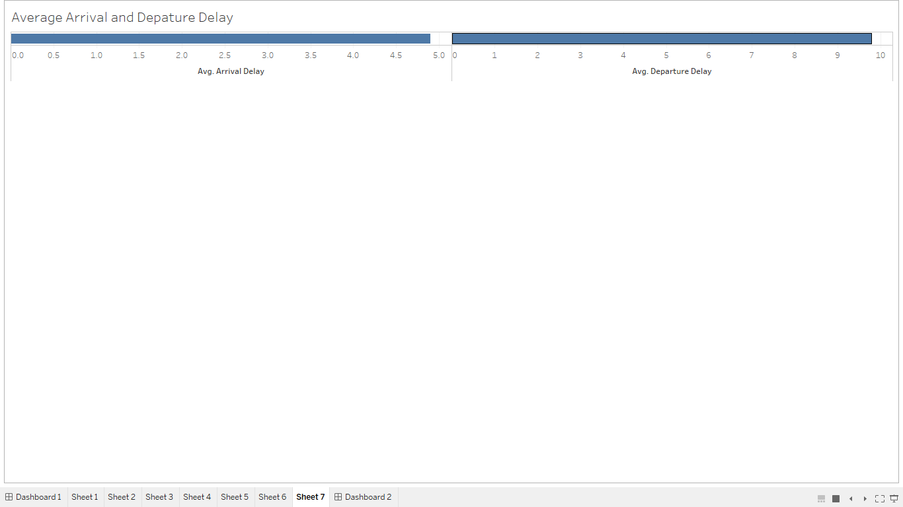

>> Avg arrival and departure delay with filter >> Without adding airport in rows.

**Screenshot 2: Screenshots of all the filter of graphs use to make a dashboard.**

**Summary :** In this dashboard we can see the Average airline delay on a map , Average airline delay by month on line chart, Average airline delay on vertical bar graph and average arrival and departure delay on horizontal bar graph. Different filters are used on all the graphs.

**Design:** In this chart I choose to color the different states’s flight cancellations bar with blue as it used for comparative analysis of flight cancellations. Doing something like red, yellow and green would be distracting the viewer from important things which is just the count of cancelled flights.

**Resources:**

NA